## ROS Guide Revision History

|  |  |  |  |  |
| --- | --- | --- | --- | --- |
| **DATE** | **Version** | **Requestor** | **Tech. Writer** | **Change/Review** |
| **3/3/17** | **1.0** |  | **Todd Singer** | **Created** |
| **3/13/17** | **1.1** |  | **WinAppEngineer** | **Verified** |
| **3/27/17** | **1.2** |  | **Todd Singer** | **Updated with new IP address for one of the DR app servers** |
| **12/10/18** | **1.3** |  | **George Young** | **Updated Contact Info** |
|  |  |  |  |  |
|  |  |  |  |  |
|  |  |  |  |  |
|  |  |  |  |  |
|  |  |  |  |  |
|  |  |  |  |  |

(New) ROS Template Overview:

This document will be used by Level 1 Operations at the GDC to troubleshoot and restore service for the servers and applications show. GDC will execute any instructions contained within based on specified parameters and technician discretion. Escalations back to the local IT staffs and local IT vendors will be made following any residual issues following execution of the pertinent steps listed in this document. Based on an overriding general agreement, escalations may also be first directed to a single point of contact such an as In Country Infrastructure Lead or In Country Orchestrator.

**Title**

6631 – United States – **HP Quality Center 12.5** (qc12.metlife.com)

**NOTE**: A completely separate ROS Guide document exists for the MetLife HP Quality Center 11.52 system (qc.metlife.com). The 11.52 system will be retired within approximately 6 months of completing the migration of all QC projects to the 12.53 system.

**Summary**

HP Quality Center (aka HP Application Lifecycle Management/Quality Center, aka Quality Center Enterprise, aka QC) provides a web-enabled system for manual and automated software quality testing across a wide range of IT and application environments. QC is designed to optimize and automate key quality activities, including requirements, test and defects management, functional testing, and business-process testing.

**Known Issues**

None.

**General Information**

HP Quality Center – aka QC, aka Quality Center Enterprise, aka QCE, aka Application Lifecycle Management, aka ALM, aka ALM/QC

**EAI code and Asset Name**

6631

HP Quality Center

**Hours of Operation and User Base**

|  |  |
| --- | --- |
| Availability: | 24 X 7 |
| Maintenance Window: | Sat 9:00 PM – Sun 5:00 AM |
| User Community: | MetLife Internal (global employees and non-employees, mostly IT associates, some non-IT associates) |

|  |  |
| --- | --- |
| User Community: | MetLife Internal |
| User Location: | Global |
| User Base Size: | Approximately 9000 |

**Escalation Groups**

|  |  |
| --- | --- |
| Group Name: | Distributed and Web Operations |
| Group Email: | Risc_OpSpecs@metlife.com |
| ServiceNow: | RISC_OpsSpecs_DistWebOps |
| OnCall: | N/A |
| *** | *** |
| Group Name: | Infra. Tech Svcs |
| Group Email: | TechOps_ITS_DotNet <techops_its_dotnet@metlife.com> |
| ServiceNow: | EIA-DAO-WinApps-GLOB |
| OnCall: | <http://msutility.metlife.com/oncall/ITS%20On-Call.htm> |
| *** | *** |

**Additional Support Groups**

|  |  |
| --- | --- |
| Engineering Group Name: | Application Platform Engineering |
| Group Email: | WindowsApplicationPlatformEngineering@metlife.com |
| ServiceNow: | EIA-DAE-App Platform Windows-L3-US |
| OnCall: | N/A |
| *** | *** |
| Database Group Name: | Data Ops - SQL Server |
| Group Email: | DB_MSSQL_Production_Support <db_mssql_production_support@metlife.com> |
| ServiceNow: | EIA-DAO-MSSQL Support-GLOB |
| OnCall: | 866-775-3227 (866-SQL-DBAS) |
| *** | *** |
| Database Group Name: | MSSQL SYBASE |
| Group Email: | DB_MSSQL_Implementation_Support <db_mssql_implementation_support@metlifedl.com> |
| ServiceNow: | EAD-GADS-MSSQL DBA Implementation Svcs-US |
| OnCall: | N/A |
| *** | *** |
| AMS Group Name: | None (contact AD) |
| *** | *** |
| AD Group Name: | Corporate Systems IT Tools |
| Email: | [wscaramastro@metlife.com](mailto:wscaramastro@metlife.com); mtomaine@metlife.com; gyoung1@metlife.com |
| ServiceNow: | EAD-CORP-Ent Technology AD-US |
| OnCall: | 1. William Scaramastro: 570-587-6125 (W), 570-650-8354 (Cell) 2. George Young: 570-585-3426(W), 570-885-5984(Cell) 3. Mark Tomaine: 570-587-6082 (W), 570-578-3895 (Cell) |

### Vendor Maintenance Contracts/Contacts

No maintenance contracts.

Software support contract with Hewlett Packard Enterprise / MicroFocus. MetLife AD group will contact vendor if it becomes necessary to do so.

### Link to IT Helpdesk DB entry and/or Application Information

**Reference to Service Now:**

**Technical Information**

**List of Servers**

|  |  |  |  |  |  |
| --- | --- | --- | --- | --- | --- |
| **Server Name** | **Function** | **Site** | **IP** | **OS** | **Env** |
| USTRY1METV00069 | App | RISC | 10.218.4.54 | Win 2012 R2 | Prod |
| USTRY1METV00070 | App | RISC | 10.218.4.234 | Win 2012 R2 | Prod |
| USTRY1METV00071 | DB (SQL 2014) | RISC | 10.218.30.231 | Win 2012 R2 | Prod |
| *** | *** | *** | *** | *** | *** |
| USCKU1METS00012 | App | SISC | 10.10.96.251 | Win 2012 R2 | DR |
| USCKU1METS00013 | App | SISC | 10.10.97.24 | Win 2012 R2 | DR |
| USCKU1METS00014 | DB (SQL 2014) | SISC | 10.90.30.191 | Win 2012 R2 | DR |
| *** | *** | *** | *** | *** | *** |
| USCKU1METE00011 | App | SISC | 10.90.200.86 | Win 2012 R2 | QA |
| USCKU1METE00012 | App | SISC | 10.90.200.47 | Win 2012 R2 | QA |
| USCKU1METE00013 | DB (SQL 2014) | SISC | 10.90.30.190 | Win 2012 R2 | QA |
| *** | *** | *** | *** | *** | *** |
| AX-SISCVMQC08 | App | SISC | 10.90.10.144 | Win 2012 R2 | Dev |
| AX-SISCVMSQL231 | DB (SQL 2014) | SISC | 10.90.9.129 | Win 2012 R2 | Dev |

**List of Databases**

|  |  |  |  |  |  |
| --- | --- | --- | --- | --- | --- |
| Server Name | DB Type | DB Instance | DB Name | Port | ID |
| USTRY1METV00071 | SQL 2014 | S6631P1 | qcsiteadmin_db_prod | 1435 | td |
| USCKU1METS00014 | SQL 2014 | S6631F1 | qcsiteadmin_db_dr | 1435 | td |
| USCKU1METE00013 | SQL 2014 | S6631Q1 | qcsiteadmin_db_qa | 1435 | td |
| AX-SISCVMSQL231 | SQL 2014 | SQL231 | qcsiteadmin_db_dev | 1435 | td |

### .NET Information: Not Applicable

### Websphere Information: Not Applicable

**MQ Information: Not Applicable**

### SiteMinder Information: Not Applicable

### SMTP Information

Prod and DR QC systems use commin.metlife.com (port 25) for sending emails (domain: test-director.com).

QA and Dev QC systems use mftest.metlife.com (port 25) for sending emails (domain: test-director.com).

### LDAP / Active Directory Information

### QC uses ldapadus.metnet.net for authenticating QC user IDs against LDAP.

### Additional Services/Processes Information

|  |  |  |  |
| --- | --- | --- | --- |
| Process Name | Directory | Tech/Version | ID |
| HP Application Lifecycle Management (ALM.exe) | Path to executable:  D:\alm_deployed\wrapper\wrapper.exe -s D:\alm_deployed\wrapper\wrapper.conf | 12.53.x | N/A |

### Networking & High Availability Configuration

**Prod**

|  |  |  |  |  |
| --- | --- | --- | --- | --- |
|  |  | IP Address | Port | System URL |
| RISC | Internal | 10.218.140.27 | 80  (80 > 443 > 8080) | <https://qc12.metlife.com/qcbin> |
| External | N/A | N/A | N/A |

**DR**

|  |  |  |  |  |
| --- | --- | --- | --- | --- |
|  |  | IP Address | Port | System URL |
| SISC | Internal | 10.90.140.22 | 80  (80 > 443 > 8080) | <https://dr.qc12.metlife.com/qcbin> |
| External | N/A | N/A | N/A |

**QA**

|  |  |  |  |  |
| --- | --- | --- | --- | --- |
|  |  | IP Address | Port | System URL |
| SISC | Internal | 10.90.140.11 | 80  (80 > 443 > 8080) | <https://qa.qc12.metlife.com/qcbin> |
| External | N/A | N/A | N/A |

**Dev**

|  |  |  |  |  |
| --- | --- | --- | --- | --- |
|  |  | IP Address | Port | System URL |
| SISC | Internal | 10.90.253.105 | 80  (80 > 443 > 8080) | <https://dev.qc12.metlife.com/qcbin> |
| External | N/A | N/A | N/A |

**Load Balancing**

|  |  |
| --- | --- |
| Keepalive Location | **Prod:**  <http://USTRY1METV00069:8080/qcbin/servlet/tdservlet>  <http://USTRY1METV00070:8080/qcbin/servlet/tdservlet>  **DR:**  <http://USCKU1METS00012:8080/qcbin/servlet/tdservlet>  <http://USCKU1METS00013:8080/qcbin/servlet/tdservlet>  tdservlet is effectively checking the ALM.exe process (HP Application Lifecycle Management service) that should be running on each app server.  When the HP ALM service (ALM.exe) is up and the tdservlet URL is accessed, the following string is returned:  com.hp.alm.platform.server.web.CTdServlet - servlet is up and running! |
| App Tier | Active/Passive  App uses port 8080 – load balancing / system URL uses port 80 which is redirected to 443 for SSL and then redirected to 8080. |
| App GSS (Y/N) | N |
| Database Tier | Active/Passive  RTO = 72 hours, RPO = 48 hours  DB backup files are generated nightly and automatically copied from Prod DB server to DR DB server. |
| Database GSS (Y/N) | N |

|  |  |
| --- | --- |
| Keepalive Location | **QA:**  <http://USCKU1METE00011:8080/qcbin/servlet/tdservlet>  <http://USCKU1METE00012:8080/qcbin/servlet/tdservlet>  See Prod/DR keepalive section for more information concerning tdservlet. |

|  |  |
| --- | --- |
| Keepalive Location | **Dev:**  <http://AX-SISCVMQC08:8080/qcbin/servlet/tdservlet>  See Prod/DR keepalive section for more information concerning tdservlet. |

**Interactions and Inter-Connectivity**

**App to App Relationship**

|  |  |  |
| --- | --- | --- |
| System | Source | Description |
| None |  |  |
|  |  |  |

**App to Service Relationship**

|  |  |  |
| --- | --- | --- |
| System | Source | Path or Invocation Method |
| None |  |  |
|  |  |  |
|  |  |  |

**Troubleshooting**

**Application Testing Procedures**

To log into a QC system, the proper matching version of the QC client components software must exist on the client machine that is being used. Therefore to test application availability, operations support associates (using their own Windows METNET ID with admin rights) should log into one of the QC app servers via Remote Desktop Connection and then try logging into the desired QC system while on the app server. The necessary QC client software already exists on the QC app servers.

1. Log into one of the QC app servers for the QC system that you want to test and start up the HP ALM Explorer client application. ALM Explorer can be started up using the app’s icon on the Windows Start screen or you can start it up using the command strings described just below.

If you start up HP ALM Explorer from its app icon on the Windows Start screen, you would need to enter into the Address field the URL of the QC system that you want to access (e.g. https://qc12.metlife.com/qcbin for Prod system) and then click the Go button.

Start HP ALM Explorer from a command prompt window (screenshots 1 and 2 below):

1. Open a DOS Command Prompt window and execute the following string:

d: & cd D:\Program Files (x86)\HP\HP ALM Explorer 12.53

1. Then execute the following command string to bring up HP ALM Explorer and to make it go to the login page of the desired QC system:

HP-ALM-Explorer.exe <QC_System_URL>

Be sure of course to replace <QC System URL> with the actual URL of the QC system that you want to access (e.g. HP-ALM-Explorer.exe https://qc12.metlife.com/qcbin).

If the HP ALM Explorer window fails to display (an IE browser window might come up in place of it), check the QC system URL string that you are passing to ALM Explorer. If it is not a completely valid correct URL, the HP ALM Explorer client will typically fail to start.

**NOTE:** Upon starting up HP ALM Explorer, if one or two “Authentication” popup windows happen to come up, leave empty all the fields in those windows and just click on the Cancel button and continue on.

**NOTE:** A QC system can also be accessed by using a direct server URL instead of using that system’s virtual load balancing URL (this information is not given out to any end users).

For example, to access the Prod QC 12.53 system directly through its primary app server the direct URL http://USTRY1METV00069:8080/qcbin can be specified when starting up HP ALM Explorer via a command prompt or when HP ALM Explorer is already running (enter the direct URL into Address field and click Go button) (QC app server names are listed above).

1. Resize (expand) the HP ALM Explorer window if desired.
2. If the login page does NOT display, it is possible (but not necessarily absolute) that the QC system is down (there may just be a problem with the QC client software on the local machine).

Make sure the service “HP Application Lifecycle Management” is up and running (i.e. “Started”) on all QC app servers that comprise that particular QC system that you are trying to access. Also refer to the *General Troubleshooting* section below for additional information.

**NOTE:** For any given QC app server, if the Startup Type of the HP ALM service is set to “Disabled” then it is likely that someone is doing some type of work on the server and therefore you should not touch the service (i.e. leave the service Disabled).

1. If the login page is displayed, enter "at663103" for Login Name and "deD1chbe" for Password and then click the Authenticate button. See screenshot 3 below.

The above Login Name and Password values should not be given out to anyone other than operations support associates.

**NOTE:** Three consecutive failed login attempts will cause the METNET ID at663103 to become locked. So if you are having trouble authenticating and logging into the QC system, you might want to verify that the ID is not locked out (check the ID in Active Directory or call the IT Help Desk).

1. If the authentication is successful, select any combination of Domain and Project values that are available in the dropdown fields for the QC Login Name that you are using (e.g. DEFAULT, ALM_Demo) and click the Login button to perform the actual log in to the selected QC project.

If the user authentication and login are successful, the HP ALM Explorer window should be showing (in left side frame) the modules that are accessible to the specific user ID that was used. See screenshot 4 below.

If the proper login name and password values were entered but the authentication and/or the login are NOT successful (e.g. if “Server not found” and/or other “error” messages get displayed to you), then it is possible that the SQL Server DB instance is down. Make sure that the SQL Server DB instance is up and running and don’t touch anything on the QC app servers (i.e. do NOT restart HP ALM service and do NOT reboot the app servers when the DB instance is down).

**Screenshot 1** – DOS Command Prompt window showing command strings that can be used to start up HP ALM Explorer client and access Prod system (https://qc12.metlife.com):

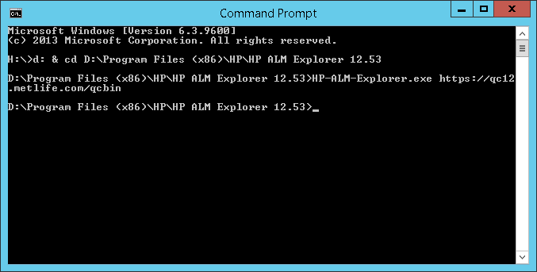

**Screenshot 2** – HP ALM Explorer displaying login page of QC system:

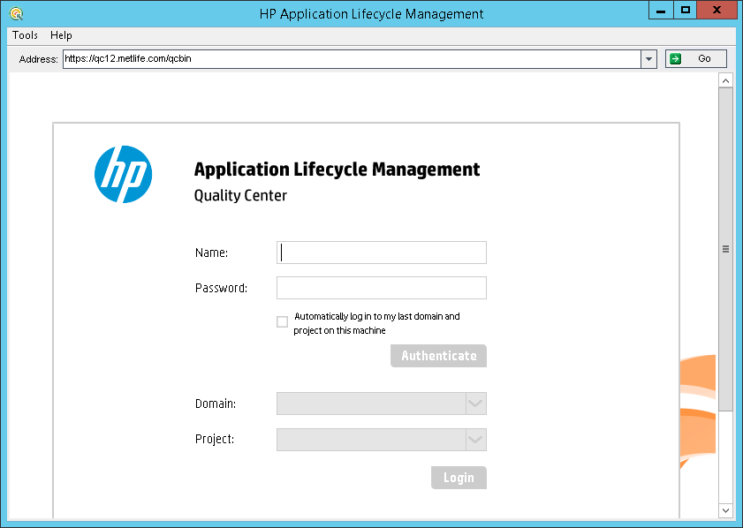

**Screenshot 3** – HP ALM Explorer showing a user ID that has been successfully authenticated it is waiting for the user to click the Login button to actually log into the selected QC project (note that a user is only able to see and log into QC projects in which that user is a member):

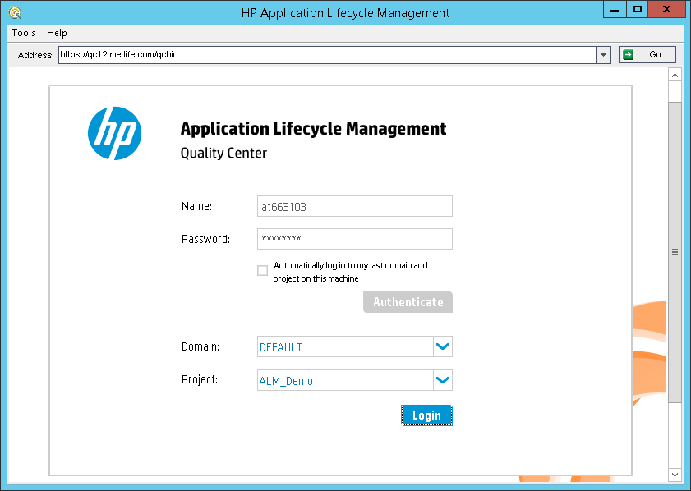

**Screenshot 4** – HP ALM Explorer showing the user logged into a QC project and viewing Defect records within the Defects module (note that what a user can view and do within a QC project is dependent on the level of access that user has within the QC project) (note that the HP ALM Explorer window may need to be expanded to show the same level of detail that is seen in this screenshot):

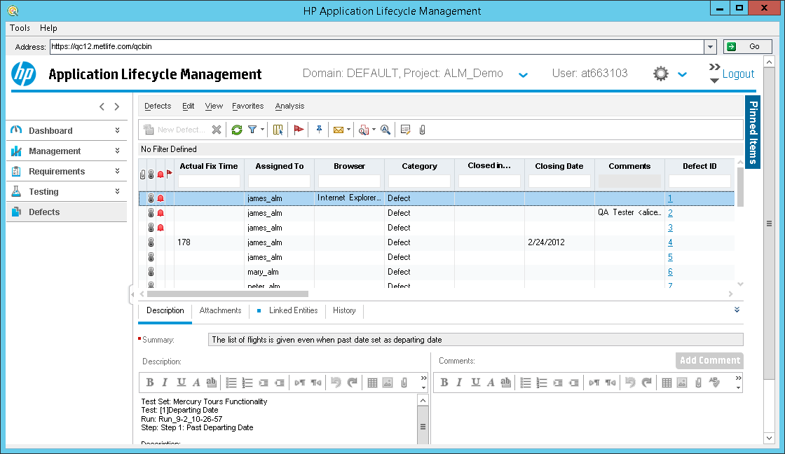

**Custom Monitoring**

Prod/DR App Servers: Windows service “HP Application Lifecycle Management” – ALM.exe (alert condition: down).

Prod/DR App Servers: Drive E (alert condition: used space > 90%).

Prod DB Server: Windows service “SQL Server (S6631P1)” – sqlsevr.exe (alert condition: down).

DR DB Server: Windows service “SQL Server (S6631F1)” – sqlsevr.exe (alert condition: down).

Prod/DR DB Servers: Drives F, G, I, J (alert condition: used space > 90%).

**Base Performance Monitoring Considerations**

None.

**Log file locations**

QC system log files are located in folder “D:\alm_deployed\log” on each app server. Log files are maintained for approximately 21 days.

**Additional Monitoring/Troubleshooting Resources**

No additional monitoring.

**General Troubleshooting**

Begin by testing application availability for the particular QC system that you are troubleshooting / investigating. See above section Application Testing Procedures for details.

If you think that something is wrong with a QC system (particularly if it is the Prod system), then before taking any action, review the information that is contained in the below sections Special Instructions and Application Startup-Shutdown Procedures.

After reviewing that information try to determine if someone or something is or was doing any work directly on the app servers that comprise the QC system (opsys patch updates, QC software updates, other work). Make sure that the database server is up and running. Also check network connectivity and load balancing (try hitting the keepalive URL of each app server that comprises the QC system; keepalive URL information is listed in above section Load Balancing).

Note that if the startup type of the HP Application Lifecycle Management service is set to Disabled and the service is stopped, leave the service alone (leave it stopped and try contacting AD for guidance). It is likely that someone may be actively doing some kind of maintenance or upgrade work on the QC system and that they have disabled and stopped the HP ALM service on purpose.

In addition to testing keepalive URLs for particular app servers, you can access a QC system directly through its app servers instead of going through the system’s load balancing URL (details can be found in above section Application Testing Procedures). Accessing and using a QC system in this manner is only for testing purposes to determine if a particular server is experiencing problems. In general end users should not be given this information.

Then based on all the information that you have gathered, decide on an appropriate course of action (e.g. if DB server is down then wait for DB server to come back online, or perhaps start/restart HP ALM service on one or more app servers, or do nothing and contact AD, or wait for network connectivity to be restored it there are networking issues).

**Startup, Shutdown and Failover Instructions**

**Special Instructions**

* Note that occasionally one or more users may report problems accessing/using the Prod QC system when it is really okay and there is just a problem with the QC client software on their local machines or a problem accessing the system via Citrix (i.e. a Citrix issue) or a problem occurring with just one of the many QC projects that exist within the system (i.e. the users and/or Help Desk may have misinterpreted one of the aforementioned problems as a complete QC system outage when the system is really okay).

Stopping and restarting the HP Application Lifecycle Management service (ALM.exe) on the QC app servers should not be considered unless there is strong evidence that multiple users from multiple locations are reporting problems trying to access/use multiple different QC projects and you have checked on other things like the database server and connectivity.

* If the underlying DB server instance that a QC system is using becomes unavailable for any reason, the HP Application Lifecycle Management service on that QC system’s app servers typically does NOT need to be recycled or restarted.

As long as the QC system remains untouched during the entire DB outage (i.e. as long as the HP ALM service is NOT recycled and the QC app servers are NOT rebooted), the QC system should start working fine again on its own once the DB instance comes back online.

If someone does happen to recycle the HP ALM service on the QC app servers or the app servers are rebooted while the DB instance is down, then the HP ALM service would need to be recycled (or QC app servers rebooted) after the DB instance comes back online.

**Application Startup-Shutdown Procedures**

The QC application essentially consists of the service HP Application Lifecycle Management (process name ALM.exe).

As long as the HP ALM service is up and running (see screenshots below), and the system’s database server is up and running, and there are no networking issues or load balancing issues, the QC system should be operating normally.

Note that if the startup type of the HP Application Lifecycle Management service is set to Disabled (or Manual) and the service is stopped, then leave the service alone and contact the AD group. It is likely that someone is actively doing some kind of maintenance or upgrade work on the QC system and that they have temporarily disabled and stopped the service on purpose.

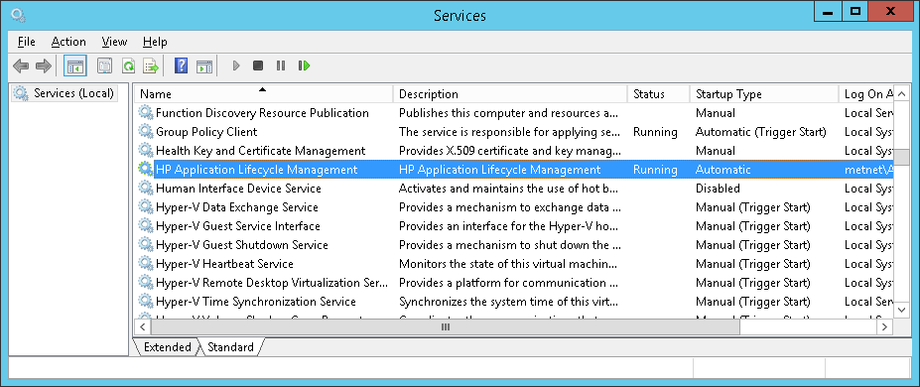

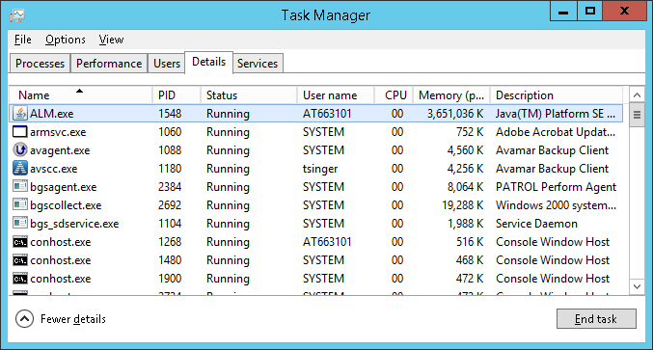

## Server and Site Failover Procedures

Any failover and failback situations need to be authorized and coordinated by the AD group.

Use of the QC Disaster Recovery system at SISC would typically only be considered when the Prod system at RISC is going to be unavailable for more than one business day. Using the DR system in place of the Prod system would be decided upon by the AD group and their management in conjunction with the QC system’s business owner.

Manual intervention is required to use the DR system as the primary QC system (and to switch back) and all necessary work would be coordinated by the AD group.

Typical steps for failover from Prod to DR system (only to be performed when AD has decided that failover should be implemented):

|  |  |  |  |  |
| --- | --- | --- | --- | --- |
| Step | Site | Task | Owner | Comments |
| 1 | RISC | Deactivate QC projects (if possible) | AD |  |
| 2 | RISC | Stop the HP Application Lifecycle Management service (ALM.exe) on Prod app servers (if possible and if deemed necessary) | DWO or AppOps |  |
| 3 | SISC | Verify that the HP Application Lifecycle Management service (ALM.exe) is up and running on DR app servers | DWO or AppOps | ALM.exe is normally always up and running on the DR app servers |
| 4 | SISC | Restore Prod DB backup files into DR DB instance | DBA | Use the Prod DB backup files that are copied to DR DB server every night |
| 5 | SISC | Configure DR QC system; add QC projects into DR QC system and activate them | AD | Use backup copies of QC project file repositories that exist on DR app servers |
| 6 | SISC | Test; log into each QC project that was added into the DR QC system | AD |  |

Typical steps for failback from DR to Prod system (only to be performed when AD has decided that failback should be implemented):

|  |  |  |  |  |
| --- | --- | --- | --- | --- |
| Step | Site | Task | Owner | Comments |
| 1 | SISC | Deactivate QC projects in DR QC system | AD |  |
| 2 | SISC | Stop the HP Application Lifecycle Management service (ALM.exe) on DR app servers | DWO or AppOps |  |
| 3 | SISC | Generate backup files for each “Prod” QC DB that currently exists in DR QC system | DBA |  |
| 4 | RISC | Restore DR DB backup files into Prod DB instance | DBA |  |
| 5 | RISC | Copy QC project file repositories from DR app servers to Prod app servers | AD | Use robocopy to sync up Prod repo folders from DR repo folders (normally the repository sync happens the other way around) |
| 6 | RISC | Configure Prod QC system; add QC projects into DR QC system and activate them | AD |  |
| 7 | RISC | Test; log into each QC project that was added into the Prod QC system | AD |  |

**Miscellaneous**

**Batch Job Dependencies**

None.

**Outside Dependencies**

None.

**Architecture Diagrams**

